**Weapon Detection using Artificial Intelligence and Deep Learning for Security Applications  
 Levels**

**A PROJECT REPORT**

submitted by

Ajay Das K, Muhammed Safeer T, Najmudheen Kp ,Fathima C

Register Number: CCV19CS002, CCV19CS016, CCV19CS018, CCV19CS006

to

the APJ Abdul Kalam Technological University

in partial fulfilment of the requirements for the award of the Degree

of

Bachelor Of Technology

In



Department of Computer Science and Engineering

**MGM COLLEGE OF ENGINEERING AND PHARAMACEUTICAL**

**SCIENCES**

VALANCHERY

MAY 2022

**DECLARATION**

I undersigned hereby declare that the main project report " **Weapon Detection using Artificial Intelligence and Deep Learning for Security Applications Levels**", submitted for partial fulfilment of the requirements for the award of degree of bachelor of Technology of the APJ Abdul Kalam Technological University, Kerala is a Bonafede work done by me under supervision of Ms Sruthi, Asst. Professor, Department of Computer Science and Engineering. This submission represents my ideas in my own words and where ideas or words of others have been included, we have adequately and accurately cited and referenced the original sources. We also declare that we have adhered to ethics of academic honesty and integrity and have not misrepresented or fabricated any data or idea or fact or source in our submission. We understand that any violation of the above will be a cause for disciplinary action by the institute and/or the University and can also evoke penal action from the sources which have thus not been properly cited or from whom proper permission has not been obtained. This report has not been previously formed the basis for the award of any degree, diploma or similar title of any other University. Place: Velachery Signature Date : 22 July 2022 Ajay Das K,Muhammed Safeer T, Najmudheen Kp ,Fathima C

Place : Velachery signature

Date: 22 July 2022 Ajay Das K

Muhammed Safeer T

Najmudheen K p

Fathima C

**DEPARTMENT OF COMPUTER SCIENCE AND ENGINEERING MGM COLLEGE OF ENGINEERING AND PHARMACEUTICAL SCIENCES, VALANCHERY**



**CERTIFICATE**

This is to certify that the project report entitled " **Weapon Detection using Artificial Intelligence and Deep Learning for Security Applications Levels**" submitted by Muhammed Safeer T (CCV19CS016) to the APJ Abdul Kalam Technological University in partial fulfilment of the requirements for the award of the Degree of Bachelor of Technology in Computer Science and Engineering is a bonafide record of the project work carried out by her under my guidance and supervision during the year 2020- 2021.This report in any form has not been submitted to any other University or Institute for any purpose

Project Coordinator Project Guide HEAD OF THE DEPT

**ACKNOWLEDGEMENT**

Success is where preparation and opportunity meet. Likewise, the present project work has been undertaken and completed with direct and indirect help from many people and I would like to acknowledge the same.

First and foremost, I take immense pleasure in thanking the Management and respected principal Dr Babu john, for providing me with the wider facilities.

We express our sincere thanks to Ms. Meera, Head of Department of Computer Science and Engineering for giving me opportunity to present this project and for timely suggestions.

I wish to express my deep sense of gratitude to the project coordinator Shabna ,Asst professor, Department of Computer Science and Engineering, who coordinated in right path. Words are inadequate in offering my thanks to Ms. Sruthy , Asst professor Department of Computer Science and Engineering, for her encouragement and guidance in carrying out the project.

Needless to mention that the teaching and the non-teaching faculty members had been the source of inspiration and timely support in the conduct of our project. We would like to express our heartfelt thanks to our beloved parents for their blessings, our classmates for their help and wishes for the successful completion of this project.

Above all we would like to thank the Almighty God for the blessings that helped us to complete the venture smoothly with us. Without their support, it would be impossible for us to finish our work. That is why we wish to dedicate this section to recognize their support.

**Ajay Das K**

**Muhammed Safeer T**

**Najmudheen Kp**

**Fathima C**

**ABSTRACT**

A major challenge in many of the object detection systems is the dependency on other computer vision techniques for helping the deep learning-based approach, which leads to slow and non-optimal performance. In this paper, a completely deep learning- based approach is used to solve the problem of object detection in an end-to-end fashion. The paper aims to incorporate state-of-the-art technique for detecting the object placed in front of the webcam with the goal of achieving high accuracy with a real-time performance using deep learning. Based on the detected image several preprogrammed robots are used to transport the object in the detected image from the place where humans cannot work flawlessly to the desired location efficiently. This paper comes with the combination of deep learning and robotics which can be used in several areas such as mines, construction sites, steel factories etc where human works in a risky environment. The network is trained on the most publicly available data set, on which an object detection challenge is conducted annually.

Keyword:- Machine Learning, object detection, Single shot detection, automation, robotics

**CONTENTS**

**CHAPTER 1**

**INTRODUCTION**

* 1. **GENERAL BACKGROUND**

When we take a look at a video or, a bunch of images we know what’s what just by taking one look, it is our innate ability that gradually developed. Well, sophisticated technologies such as object detection can do that too. It might sound futuristic but it is happening now in reality. Object detection is a technique of the AI subset computer vision that is concerned with identifying objects and defining those by placing into distinct categories such as humans, cars, animals etc.

It combines machine learning and deep learning to enable machines to identify different objects. However, image recognition and object detection these terms are often used interchangeably but, both techniques are different. Object detection could detect multiple objects in an image or, in a video. The demand for trained experts in this field is pretty high and having a background in **deep learning for computer vision with python** can help one build a dream career.

Object detection has found applications across industries. Let’s take a look at some of these applications

**Tracking objects**

It is needless to point out that in the field of security and surveillance object detection would play an even more important role. With object tracking it would be easier to track a person in a video. Object tracking could also be used in tracking the motion of a ball during a match. In the field of traffic monitoring too object tracking plays a crucial role.

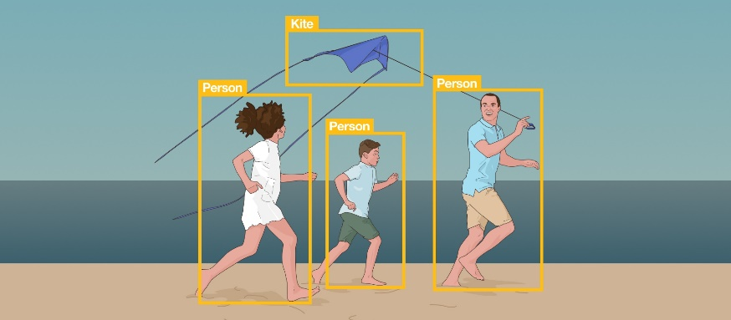

#### Counting the crowd

Crowd counting or people counting is another significant application of object detection. During a big festival, or, in a crowded mall this application comes in handy as it helps in dissecting the crowd and measure different groups.

#### Self-driving cars

Another unique application of object detection technique is definitely self-driving cars.  A self-driving car can only navigate through a street safely if it could detect all the objects such as people, other cars, road signs on the road, in order to decide what action to take.

#### Detecting a vehicle

In a road full of speeding vehicles object detection can help in a big way by tracking a particular vehicle and even its number plate. So, if a car gets into an accident or, breaks traffic rules then it is easier to detect that particular car using object detection model and thereby decreasing the rate of crime while enhancing security

.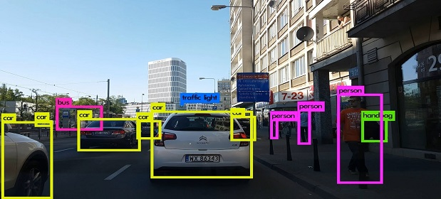

#### Detecting anomaly

Another useful application of object detection is definitely spotting an anomaly and it has industry specific usages.  For instance, in the field of agriculture object detection helps in identifying infected crops and thereby helps the farmers take measures accordingly.  It could also help identify skin problems in healthcare.  In the manufacturing industry the object detection technique can help in detecting problematic parts really fast and thereby allow the company to take the right step.

Object detection technology has the potential to transform our world in multiple ways. However, the models still need to be developed further so that these can be applied across devices and platforms in real-time to offer cutting-edge solutions.

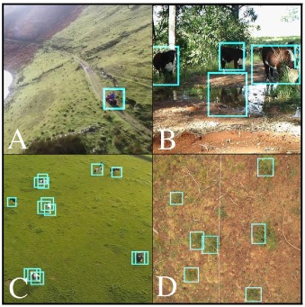

**MOTIVATION**

Automatic target detection plays a major role in automated war operations. The key concept behind automated target detection is military objects recognition from the captured images. For object recognition in the given image, Convolutional Neural Network (CNN) is a powerful classification network. But in general CNNs are trained for general object recognition. But, the performance of CNN depends mainly on the size of the training set. The size of the training data is generally available in less proportion for military objects due to its operational and security issues. Hence the performance of CNN may degrade sharply. To address the issue of military objects, a relatively new neural network architecture called Capsule Network (CapsNet) is introduced. Hence, in this article, a variant of CapsNet called Multi-level CapsNet framework is projected for military object recognition under the case of small training set. The introduced framework of this paper is validated on a dataset of military objects which are collected from the internet. The dataset contains particularly five military objects and the similar civil ones. The proposed framework demonstrates a large improvement of 96.54% of accuracy for military object recognition. Experiments demonstrate that the proposed framework can accomplish a high recognition precision, superior to many other algorithms such as conventional Support Vector Machines and transfer learning based CNNs.

So we decided to make a REAL TIME OBJECT DETECTION System. We are interested in this project after we went through few papers in this area. As a result we are highly motivated to develop a system that recognizes objects in the real time environment

**OBJECTIVE**

In this paper we proposed efficient and accurate object detection has been an important topic in the advancement of computer vision systems. With the advent of deep learning techniques, the accuracy for object detection has increased drastically. A major challenge in many of the object detection systems is the dependency on other computer vision techniques for helping the deep learning- based approach, which leads to slow and non-optimal performance. The main aim of object detection is to find the exact location of an object in each picture accurately and mark. This can be applicable military and many other fields.

**PROJECT OUTLINE**

The project report is organized in such a way that, first part includes the introduction section which explains the General Background, Objectives of the project,Scope of the project and the Organization of thesis in detail. In the second section literature survey is included. Third section is proposed system which contains System architecture and Module description,and fourth section is the expected outcome and then the last section is references.

**CHAPTER 2**

**LITERATURE SURVEY**

2**.1. R-CNN (Region based convolutional neural network)**

To find a way around the problem of choosing a vast number of regions, Ross Girshick et al. papered a method in which he use a discriminating search to dig out just 2000 regions from a image and he called them region proposals. Therefore, now, as an alternative of trying to categorize a huge number of regions, we can just effort with 2000 regions.

**2.2. Fast R-CNN**

The similar author of earlier paper (R- CNN) also solved some of drawback of R-CNN to construct the object detection algorithm called fast R-CNN. This algorithm is similar to the previous R-CNN algorithm. But instead feed region proposals to CNN, we can provide the input image to build the convolutional map. This is fast than R-CNN because there is no need to feed proposals of 2000 region to convolutional neural network each time. Instead of this, the convolution operation is made only one time per image and a feature map generates from it.

**2.3. Faster R-CNN**

R-CNN & Fast R-CNN finds region proposal using selective search. This is a timeconsuming & slow process which affects the performance of network. Due to this problem, Shaoqing Ren et al. built an algorithm of object detection that eliminate the discriminating search algorithm and let the network learn the region proposal. Same as fast R-CNN, the image is provided to a convolutional network as an input that will provide the convolutional feature map. A different network is used to guess the region proposals instead using of selective search algorithm on the feature map to recognize the region proposals. Reshaping of the region proposals which are predicted is done using a RoI pooling layer which classifies the image within the planned region and guess the offset value for bounding boxes.

**2.4. YOLO (You Only Look Once)**

All of the earlier object detection algorithms use regions to localize the object inside the image. Apart from the above seen algorithms which are region based, You Only Look Once or YOLO is an algorithm based on object detection which is much different. The only convolutional network predicts the bounding boxes and the class probabilities for these boxes in YOLO.

**2.5. SSD (Single Shot Detection)**

A one single shot can be taken to detect numerous objects inside the image in SSD, while regional proposal network (RPN) approaches such as R- CNN series which requires two shots, one for proposal of generating regions and the other for detection of object of every proposal. Hence, SSD is faster than RPN based approach.

**CHAPTER 3**

**PROPOSED SYSTEM**

**PROBLEM STATEMENT**

The major challenge in this problem is that of the variable dimension of the output which is caused due to the variable number of objects that can be present in any given input image. Any general deep learning task requires a fixed dimension of input and output for the model to be trained. Another important obstacle for widespread adoption of object detection systems is the requirement of real-time (30fps) while being accurate in detection. The more complex the model is, the more time it requires for inference; and the less complex the model is, the less is the accuracy. This trade-off between accuracy and performance needs to be chosen as per the application. Classifications as well as regression are the major problems involved which is leading the model to be learnt simultaneously. This adds to the complexity of the problem. A lot of work is there in object detection by the use of traditional computer vision techniques (sliding windows, deformable part models). However, lack of accuracy of deep learning-based techniques. Among the deep learning-based techniques, two broad class of methods are prevalent: two stage detection (RCNN [1], Fast RCNN [2], Faster RCNN [3]) and unified detection (Yolo [4], SSD [5]. The robot used here follows a line to transport the object from source to destination; the irregularity in the line can make the robot to halt unnecessarily. Moreover, the path surface should be even so that the carrier robot can move back and forth flawlessly.

**PROPOSED METHDOLOGY**

4.1 SSD Sliding window detection, as its name suggests, slides a local window across the image and identifies at each location whether the window contains any object of interests or not. Multi-scale increases the robustness of the detection by considering windows of different sizes. Such a brute force strategy can be unreliable and expensive: successful detection requests the right information being sampled from the image, which usually means a fine-grained resolution to slide the window and testing a large cardinality of local windows at each location. Input and Output: The input to an SSD is an image which is of fixed size, for example, 512x512 image for SSD512. The fixed size constraint is mainly for efficient training with batched data. Being fully convolutional, the network can run inference on images of different sizes. The output of SSD is a prediction map. Each location in this map stores classes confidence and bounding box information as there are indeed an object of interests in every location. Obviously, there will be a lot of false alarms, so a further process is used to select a list of most likely prediction based on simple heuristics.

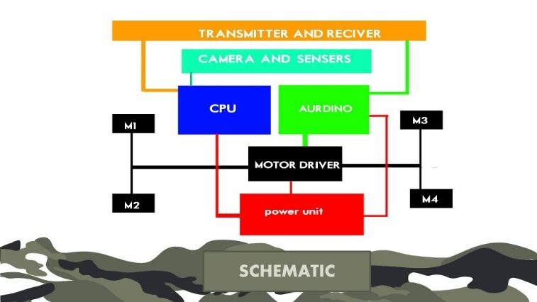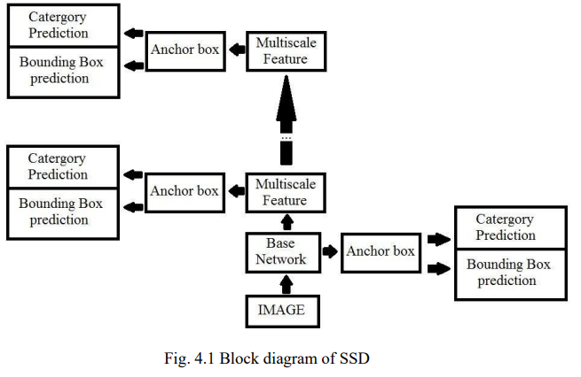

**MODULE DESCRIPTION**

**Acrylic Sheets**

* Acrylic is a transparent plastic material with outstanding strength, stiffness, and optical clarity
* Acrylic sheet is easy to fabricate, bonds well with adhesives and solvents, and is easy to thermoform.
* It has superior weathering properties compared to many other transparent plastics.

**3d printed wheels**

* 3D printing or additive manufacturing is the construction of a three-dimensional object from a CAD model or a digital 3D model.
* It can be done in a variety of processes in which material is deposited, joined or solidified under computer control, with material being added together, typically layer by layer.

For cad [www.thingivers](files:https://www.thingiverse.com/thing:1462917)

Video:[www.youtube.com](https://www.youtube.com/watch?v=Cy6zA4NFGd4)

**Gear motor**

* A gearmotor(or geared motor) is a small electric motor (AC induction, permanent magnet DC, or brushless DC) designed with an integral (non-separable) gear reducer (gearhead) attached
* Working of gear motor:
* [You tube](https://www.youtube.com/watch?v=B_u99Pt62qA)

**L298n motor driver**

* The L298N is a dual H-Bridge motor driver which allows speed and direction control of two DC motors at the same time.
* The module can drive DC motors that have voltages between 5 and 35V, with a peak current up to 2A.
* L298n motor driver working:[You tube](https://www.youtube.com/watch?v=PVyAcgYkzDs)

**Aurdino board**

* Arduino is an open-source electronics platform based on easy-to-use hardware and software.
* Arduino boards are able to read inputs - light on a sensor, a finger on a button, or a Twitter message - and turn it into an output - activating a motor, turning on an LED, publishing something online.

**Arduino Software (IDE)**

* The Arduino Integrated Development Environment - or Arduino Software (IDE) - contains a text editor for writing code, a message area, a text console, a toolbar with buttons for common functions and a series of menus.
* It connects to the Arduino hardware to upload programs and communicate with them.

**Arduino program**

* Arduino code is written in C++ with an addition of special methods and functions, which we’ll mention later on.
* C++ is a human-readable programming language. When you create a ‘sketch’ (the name given to Arduino code files), it is processed and compiled to machine language.
* The program code:  Drone code

**Hc05 Bluetooth module**

* HC-05 Bluetooth Module is an easy to use Bluetooth SPP (Serial Port Protocol) module, designed for transparent wireless serial connection setup.
* Its communication is via serial communication which makes an easy way to interface with controller or PC.

**LED lights**

* The light-emitting diode (LED) is today's most energy-efficient and rapidly-developing lighting technology.
* Quality LED light bulbs last longer, are more durable, and offer comparable or better light quality than other types of lighting.

**Li Ion Battery and B M S Circuit**

* A lithium-ion battery
* Li-ion battery is a type of rechargeable battery composed of cells in which lithium ions move from the negative electrode through an electrolyte to the positive electrode during discharge and back when charging.
* Li-ion battery BMS
* A BMS (Battery Management System) is essential in a Lithium-Ion battery system. This device manages a real-time control of each battery cell, communicates with external devices, manages SOC calculation, measures temperature and voltage, etc.

**The rover controlling app Project Rower RC**

The app is built for communicating the RC rover and smartphone through the Bluetooth medium

By the controller we can control the rover speed, movements and 4 additional channels used for destructions, lights, and signaling.

**IMPLEMENTATION**

The RC drone Is controlled with

**THE CONSIDERED ARCHITECTURE**

The idea behind the scheme is YOLO algorithm. Compared to the approach taken by object detection algorithms before YOLO, which repurpose classifiers to perform detection, YOLO proposes the use of an end-to-end neural network that makes predictions of bounding boxes and class probabilities all at once.

Following a fundamentally different approach to object detection, YOLO achieves state-of-the-art results beating other real-time object detection algorithms by a large margin.

In addition to increased accuracy in predictions and a better Intersection over Union in bounding boxes (compared to real-time object detectors), YOLO has the inherent advantage of speed.

YOLO is a much faster algorithm than its counterparts, running at as high as 45 FPS.

While algorithms like Faster RCNN work by detecting possible regions of interest using the Region Proposal Network and then perform recognition on those regions separately, YOLO performs all of its predictions with the help of a single fully connected layer.

Methods that use Region Proposal Networks thus end up performing multiple iterations for the same image, while YOLO gets away with a single iteration.  The YOLO algorithm works by dividing the image into N grids, each having an equal dimensional region of SxS. Each of these N grids is responsible for the detection and localization of the object it contains.

Correspondingly, these grids predict B bounding box coordinates relative to their cell coordinates, along with the object label and probability of the object being present in the cell.

This process greatly lowers the computation as both detection and recognition are handled by cells from the image, but It brings forth a lot of duplicate predictions due to multiple cells predicting the same object with different bounding box predictions.

YOLO makes use of Non Maximal Suppression to deal with this issue.

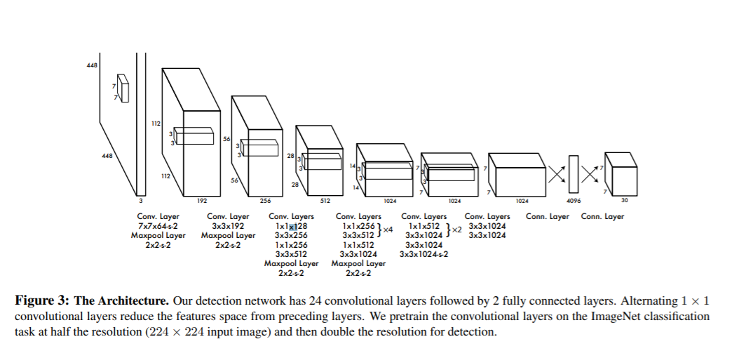

**CHAPTER 4**

**DATA SETS**

**DA** Creating a custom model to detect your objects is an iterative process of collecting and organizing images, labeling your objects of interest, training a model, deploying it into the wild to make predictions, and then using that deployed model to collect examples of edge cases to repeat and improve.

### **1. Create Dataset**

YOLOv5 models must be trained on labelled data in order to learn classes of objects in that data. There are two options for creating your dataset before you start training:

**Collect Images**

Your model will learn by example. Training on images similar to the ones it will see in the wild is of the utmost importance. Ideally, you will collect a wide variety of images from the same configuration (camera, angle, lighting, etc) as you will ultimately deploy your project.If this is not possible, you can start from a public dataset to train your initial model and then sample images from the wild during inference to improve your dataset and model iteratively.

### **Create Labels**

Once you have collected images, you will need to annotate the objects of interest to create a ground truth for your model to learn from. Roboflow Annotate is a simple web-based tool for managing and labeling your images with your team and exporting them in YOLOv5's annotation format.

**CHAPTER 5**

**EXPERIMENTAL RESULTS**

**5.1 TRAINING THE DATA**

Train a YOLOv5s model on COCO128 by specifying dataset, batch-size, image size and either pre-trained --weights yolov5s.pt (recommended), or randomly initialized --weights '' --cfg yolov5s.yaml (not recommended). Pre-trained weights are auto-downloaded from the latest YOLOv5 release.

# Train YOLOv5s on COCO128 for 3 epochs

$ python train.py --img 640 --batch 16 --epochs 3 --data coco128.yaml --weights yolov5s.pt

All training results are saved to runs/train/ with incrementing run directories, i.e. runs/train/exp2, runs/train/exp3 etc.

#### 5.2 Local Logging

All results are logged by default to runs/train, with a new experiment directory created for each new training as runs/train/exp2, runs/train/exp3, etc. View train and val jpgs to see mosaics, labels, predictions and augmentation effects. Note an Ultralytics **Mosaic Dataloader** is used for training (shown below), which combines 4 images into 1 mosaic during training.

train_batch0.jpg shows train batch 0 mosaics and labels:

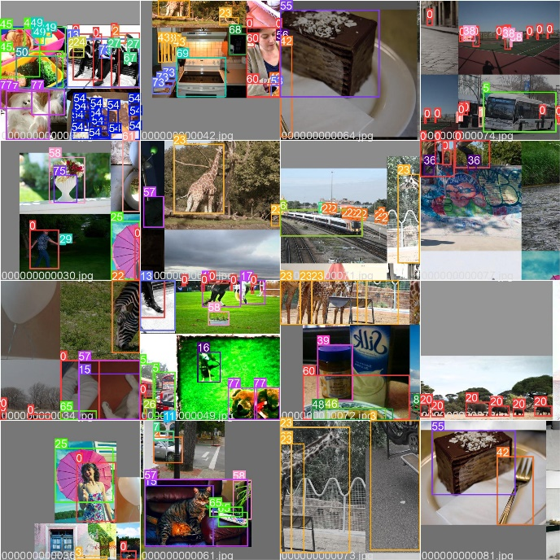

val_batch0_labels.jpg shows val batch 0 labels:

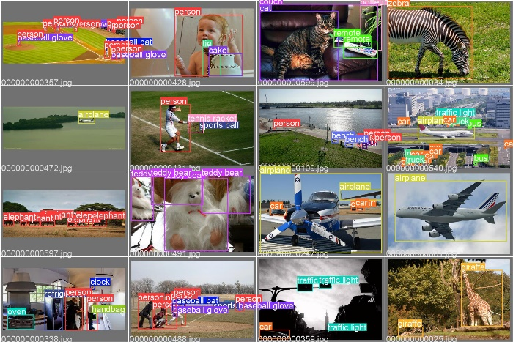

val_batch0_pred.jpg shows val batch 0 predictions:

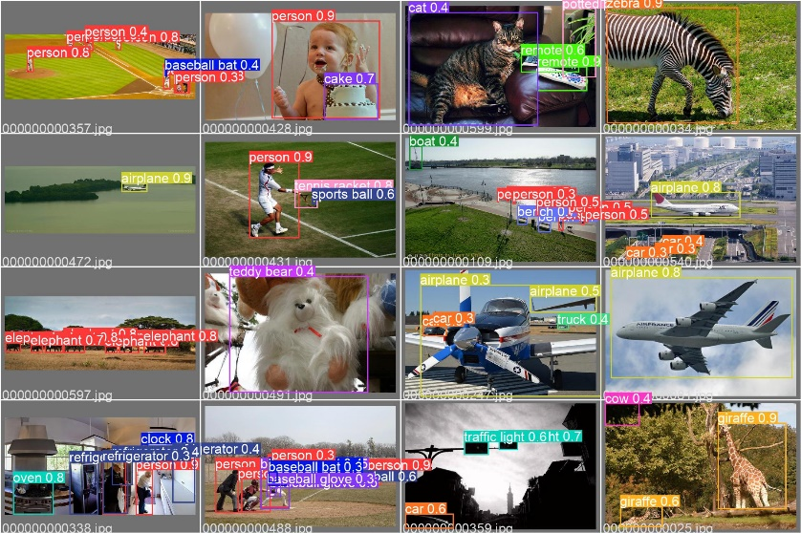

**5.3 PERFORMANCE ANALYSIS**

Training results are automatically logged to Tensorboard and CSV as results.csv, which is plotted as results.png (below) after training completes. You can also plot any results.csv file manually:

from utils.plots import plot_results

plot_results('path/to/results.csv') # plot 'results.csv' as 'results.png'

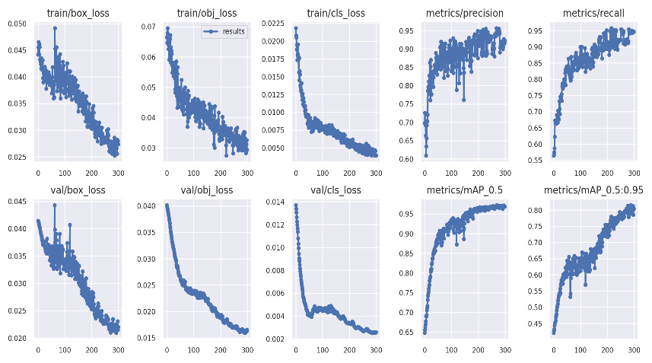

**5.4 EVALUATION OF PROPOSED METHOD**

The first YOLO model was introduced by Joseph Redmon et all in their 2015 [paper](https://arxiv.org/pdf/1506.02640.pdf) titled “You Only Look Once: Unified, Real-Time Object Detection”. Till that time RCNN models were the most sought-after models for object detection. Although the RCNN family of models were accurate but were relatively slow because it was a multi-step process of finding the proposed region for the bounding box and then do classification on these regions and finally do post-processing to refine the output. YOLO was created with the goal to do away with multistage and perform object detection in just a single stage, thus increasing the inference time.

**CHAPTER 6 CONCLUSION**